***Public Transport System Management***

**IS 301 Enterprise Integration**

***G2-3***

**Assignment**

***EUGENE CHOY WEN JIA***

***HO MIN KIT WINSTON***

***HO WEI HONG***

***SIM LI JIN***

***YIN YUKUN***

***YONG FU XIANG***

# Introduction

The Public Transport network in Singapore serves hundreds of thousand passengers every day. Any disruption in the service could be disastrous and mitigation actions must be undertaken to ensure minimal disruptions to the passengers. Integrations of various system in the Public Transport Network is therefore important to help enhance communication and automate processes if mitigation actions are required.

On top of having to mitigate disruptions, there are also other processes such as checking the weather to determine the speed of travel and the bus schedules of bus drives which requires several steps before the message can be transferred from one end to the other. Using integration tools, we can automate a huge bulk of this process reducing the time needed for human intervention.

# Business Scenario

## Technical Overview Diagram

## Train Breakdown Process

## Weather Reporting Process

## Bus Schedule Process

*[Write-up of the scenario flow with reference to the Technical Overview Diagram and Process Definition Diagram(s)]*

# JMS Interactions

|  |  |  |  |  |  |  |
| --- | --- | --- | --- | --- | --- | --- |
| JMS Integration | From | To | *FF/  SRR/  ARR | Publish-Subscribe or Point-to-Point | JMS Queue/Topic (or Topic with durable subscription) | Queue/Topic Name used (case-sensitive) |
| Integration 1 |  |  |  |  |  |  |
|  |  |  |  |  |
| Integration 2 |  |  |  |  |  |  |
|  |  |  |  |  |

…

**\* Legend**  
FF - Fire & Forget

SRR - Sync Request/Reply

ARR - Async Request/Reply

# Web Services

|  |  |  |  |  |
| --- | --- | --- | --- | --- |
| Service | Description | Protocol | Input | Output |
| *[Service Name]* | *[Short Description of what the service does]*  *[Self-coded/existing service – hosted on http://…]* | REST/SOAP | *State the format, then list the fields involved*  *e.g.*  *JSON*  *name, age, nric* | *As per Input* |

…

# 

# Design/Schema and Content of Data

*Database*

*…*

*XSD*

*E.g. order.xsd*

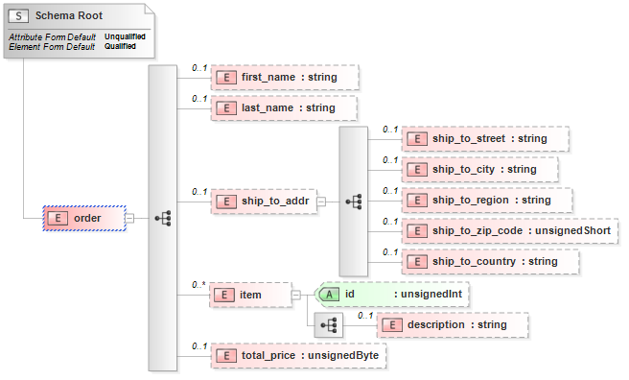

…   
*You will need to show the sample content as well*

*JSON*

…

# Data Transformation

*[For each transformation, indicate the source and destination names and the system(s) involved]*

*[Include a diagram]*

*E.g. Between OdMS (new_order.xsd) and COMS (corporate_order.xsd)*

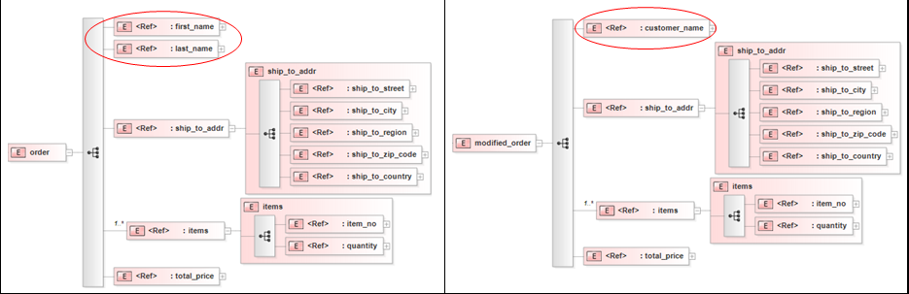

…

# 

# Content-based Routing

*[For each content-based routing, indicate the condition(s) used, the method used for determining the route and the destination system(s)/service(s)]*

# 

# Beyond the Labs

*[List, describe and explain the things you have done beyond the labs]*

# Scenario Walkthrough (Max 10 Pages)

*[Walkthrough of your demonstration, using screen captures. Screens captured must be viewable when the document is displayed at 100% zoom scale]*